**90. Module Introduction**

* -: Time to take another look at directives, and not only repeat quickly what we learned thus far, but also learn how to build our own directives.
* And then we dive into the difference between attribute and structural directives, and what this star means on the structural directives.
* Well, I already said it, right? We got attribute and structural directives.

**Attribute directives**

* Attribute directives are called like this because they sit on elements, Just like attributes,
* **Structural Attributes:**
* structural directives basically do the same, but they also *change the structure of the DOM around this element.*

*EG:*

* If you have NGF on a paragraph, if that condition is false, this paragraph is removed from the DOM, so the overall view container is affected, whereas on the attribute directive, you never destroy an element from the DOM, you only change properties of that element, for example, the background color.
* So, that is why we have attribute directives only affecting the element they sit on, and structural directives, which also affect the whole DOM or the view container, the area around the element which they were placed on.
* That is the difference.
* 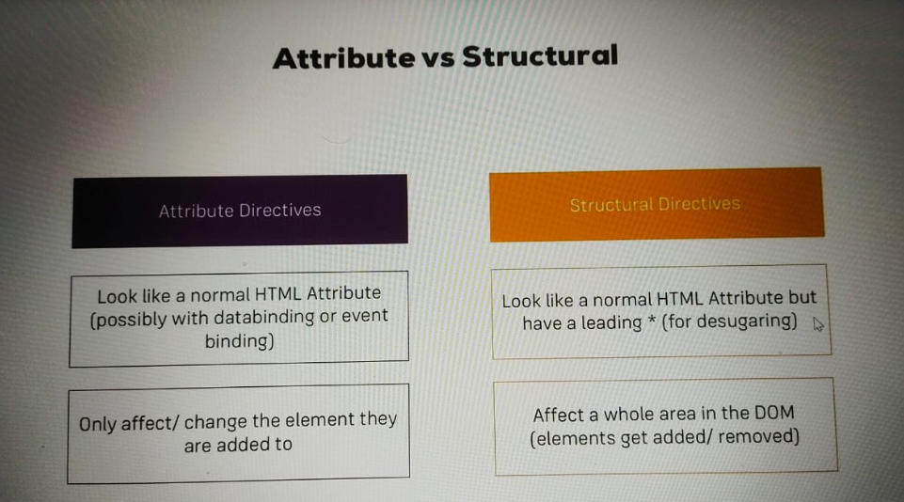
* Now, let's briefly have a look at the directives we already know and how to use them, before we then dive into building our own ones, and learn more about structural directives.